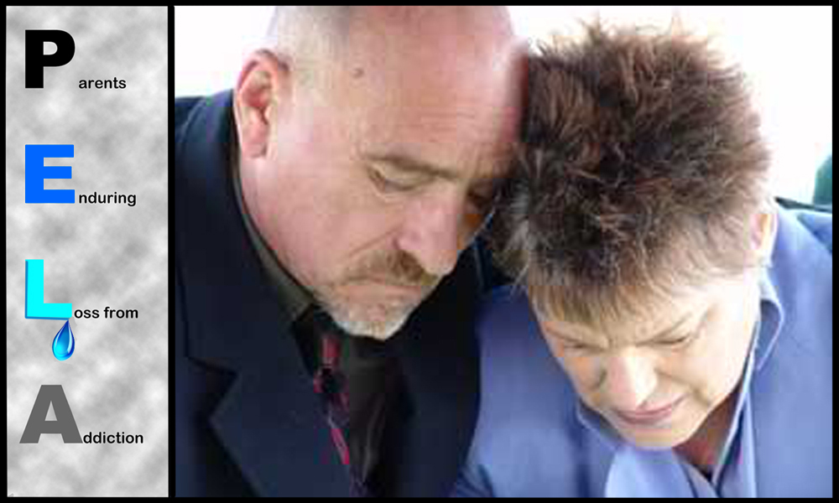

There are many quality grief groups in our area, but PELA is the only one for parents who have lost a child of any age to an
addiction.

PELA is a free support group facilitated by Charlie Berman, a Licensed Professional Counselor (LPC) and a Licensed Clinical Alcohol and Drug Counselor (LCADC) — but most importantly, he too has lost his daughter so he knows the kind of pain you are experiencing.

PELA, a program of Willow Tree Counseling Associates, is held the 3rd Wednesday of every month from 5:30 to 7pm in Fellowship Hall of the First Presbyterian Church of New Vernon. If using a GPS, insert the following address: 2 Lees Hill Road, Basking Ridge, NJ. No pre-registration is required. Please join us.

Willow Tree Counseling Associates^{LLC} can help in other ways as well. We offer:

- Addiction Assessments,
- Family Interventions,
- Counseling for individuals and couples,
- Three wellness groups: Flourishing Skills Group, Willow Women & Bounce Back Better (lessons in Resiliency).

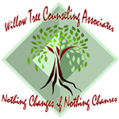
NEED HELP?

Contact the Willow Tree Counseling Associates via 201-602-7523, www.willowtree.org or
email Charlie at Charlie@willowtree.org

